Universitatea Tehnică a Moldovei

FCIM

Departamentul de Informatica si Inginerie Software

# **RAPORT**

la lucrarea de laborator nr. 1

# la disciplina PAM

**Tema:** “UI View Model - Lucrarea Nr.1”

A efectuat: Zavorot Daniel st. gr. TI-194

A verificat: asistent universitar C.Rusu

**Chisinau – 2021**

**Obiective:** Dezvoltarea unei aplicații pe una din platformele stabilite la Laboratorul Nr.0 , utilizând mediul de dezvoltare corespunzător acesteia.

**Scopul:**De prezentat o aplicație ce rulează pe un dispozitiv sau emulator, ce va conține pe interfața sa, următoarele elemente:

1. 4 butoane (ce vor executa condițiile de mai jos)
2. 1 TextBox (pentru input)
3. 2 Radio butoane (pentru camera față, spate)

[**Condiții**](https://else.fcim.utm.md/mod/page/view.php?id=27261)**:**

De utilizat componentele UI pentru a realiza următoarele [condiții](https://else.fcim.utm.md/mod/page/view.php?id=27261" \o "Condiții):

1. De creat un **push notification** pe ecranul dispozitivului care se va trata peste **10s**.
2. De utilizat browserul intern al dispozitivului, pentru a inițializa **o căutare în Google**, conform **cuvântului cheie** introdus în **TextBox**.
3. De rulat **evenimentul de lucru a camerei** frontale și/sau spate la selectarea unuia din cele 2 radio butoane propuse.
4. De tratat**evenimentul de captare** a pozei executate cu una din cele doua camere, și de **afișat într-o altă Activitate**
5. Este un punct la dorința voastră (sau un brainstorming)

**JAVA MainActivity:**

package com.example.pam_lab1;  
  
import androidx.annotation.NonNull;  
import androidx.appcompat.app.AppCompatActivity;  
import androidx.camera.core.CameraSelector;  
import androidx.camera.core.ImageCapture;  
import androidx.camera.core.ImageCaptureException;  
import androidx.camera.core.Preview;  
import androidx.camera.lifecycle.ProcessCameraProvider;  
import androidx.camera.view.PreviewView;  
import androidx.core.app.NotificationCompat;  
import androidx.core.app.NotificationManagerCompat;  
import androidx.core.content.ContextCompat;  
import androidx.lifecycle.LifecycleOwner;  
  
import android.app.PendingIntent;  
import android.content.Intent;  
import android.graphics.Bitmap;  
import android.graphics.BitmapFactory;  
import android.net.Uri;  
import android.os.Bundle;  
import android.os.CountDownTimer;  
import android.os.Environment;  
import android.view.View;  
import android.widget.Button;  
import android.widget.EditText;  
import android.widget.RadioButton;  
import android.widget.Toast;  
  
import com.google.common.util.concurrent.ListenableFuture;  
  
import java.io.ByteArrayOutputStream;  
import java.io.File;  
import java.util.Date;  
import java.util.concurrent.Executor;  
  
public class MainActivity extends AppCompatActivity {  
 private ListenableFuture<ProcessCameraProvider> cameraProviderFuture;  
 PreviewView previewView;  
 private ImageCapture imageCapture;  
 private RadioButton radioBack, radioFront;  
 private EditText textbox;  
  
 @Override  
 protected void onCreate(Bundle savedInstanceState) {  
 super.onCreate(savedInstanceState);  
 setContentView(R.layout.*activity_main*);  
  
 previewView = findViewById(R.id.*previewView*);  
 previewView.setRotation(180);  
 radioBack = findViewById(R.id.*radioBack*);  
 radioBack.setChecked(true);  
 radioFront = findViewById(R.id.*radioFront*);  
 textbox = findViewById(R.id.*textbox*);  
  
  
  
 cameraProviderFuture = ProcessCameraProvider.*getInstance*(MainActivity.this);  
 cameraProviderFuture.addListener(()-> {  
 try {  
 ProcessCameraProvider cameraProvider = cameraProviderFuture.get();  
 startCameraX(cameraProvider, 0);  
 } catch (Exception e) {  
 e.printStackTrace();  
 }  
 }, getExecutor());  
  
 *// Notification* final Button button = findViewById(R.id.*btn1*);  
 button.setOnClickListener(new View.OnClickListener() {  
 public void onClick(View v) {  
  
 Intent resultIntent = new Intent(MainActivity.this, MainActivity.class);  
 PendingIntent resultPendingIntent = PendingIntent.*getActivity*(MainActivity.this, 1, resultIntent, PendingIntent.*FLAG_UPDATE_CURRENT*);  
  
  
 NotificationCompat.Builder mBuilder = new NotificationCompat.Builder(MainActivity.this, "My notification")  
 .setSmallIcon(R.drawable.*ic_launcher_background*)  
 .setContentTitle("PAM Lab.1")  
 .setContentText("Click pentru a deschide aplicatia.")  
 .setAutoCancel(true)  
 .setContentIntent(resultPendingIntent)  
 .setPriority(NotificationCompat.*PRIORITY_MAX*);  
  
 Toast.*makeText*(MainActivity.this, "Notificarea va aparea peste 10 secunde.", Toast.*LENGTH_SHORT*).show();  
 new CountDownTimer(10000, 1000){  
 public void onTick(long millisUntilFinished){  
  
 }  
 public void onFinish(){  
 NotificationManagerCompat mng = NotificationManagerCompat.*from*(MainActivity.this);  
 mng.notify(1, mBuilder.build());  
 }  
 }.start();  
 }  
 });  
  
  
  
 *// Browser* final Button button3 = findViewById(R.id.*btn3*);  
 button3.setOnClickListener(new View.OnClickListener() {  
 public void onClick(View v) {  
 String key = textbox.getText().toString();  
 if (key.equals("")) {  
 Toast.*makeText*(MainActivity.this, "Introduceti cuvantul cheie.", Toast.*LENGTH_SHORT*).show();  
 }  
 else {  
 Intent browserIntent = new Intent(Intent.*ACTION_VIEW*, Uri.*parse*("https://www.google.com/search?q=" + key));  
 startActivity(browserIntent);  
 textbox.setText("");  
 }  
 }  
 });  
  
 *// Toggle* final Button button2 = findViewById(R.id.*btn2*);  
 button2.setOnClickListener(new View.OnClickListener() {  
 public void onClick(View v) {  
 if(radioBack.isChecked()){  
 cameraProviderFuture.addListener(()-> {  
 try {  
 ProcessCameraProvider cameraProvider = cameraProviderFuture.get();  
 startCameraX(cameraProvider, 0);  
 } catch (Exception e) {  
 e.printStackTrace();  
 }  
 }, getExecutor());  
  
 }  
 else {  
 if(radioFront.isChecked()) {  
 cameraProviderFuture.addListener(()-> {  
 try {  
 ProcessCameraProvider cameraProvider = cameraProviderFuture.get();  
 startCameraX(cameraProvider, 1);  
 } catch (Exception e) {  
 e.printStackTrace();  
 }  
 }, getExecutor());  
 }  
 }  
  
  
 }  
  
 });  
  
 *// Photo* final Button button4 = findViewById(R.id.*btn4*);  
 button4.setOnClickListener(new View.OnClickListener() {  
 public void onClick(View v) {  
 capturePhoto();  
 }  
 });  
 }  
  
 private Executor getExecutor(){  
 return ContextCompat.*getMainExecutor*(MainActivity.this);  
 }  
  
 private void startCameraX(ProcessCameraProvider cameraProvider, int id){  
 cameraProvider.unbindAll();  
 if(id == 0) {  
 CameraSelector cameraSelector = new CameraSelector.Builder()  
 .requireLensFacing(CameraSelector.*LENS_FACING_BACK*)  
 .build();  
  
  
  
 Preview preview = new Preview.Builder().build();  
 preview.setSurfaceProvider(previewView.getSurfaceProvider());  
  
 imageCapture = new ImageCapture.Builder()  
 .setCaptureMode(ImageCapture.*CAPTURE_MODE_MINIMIZE_LATENCY*)  
 .build();  
  
 cameraProvider.bindToLifecycle((LifecycleOwner) this, cameraSelector, preview, imageCapture);  
 }  
 else{  
 CameraSelector cameraSelector = new CameraSelector.Builder()  
 .requireLensFacing(CameraSelector.*LENS_FACING_FRONT*)  
 .build();  
  
 Preview preview = new Preview.Builder().build();  
 preview.setSurfaceProvider(previewView.getSurfaceProvider());  
  
 imageCapture = new ImageCapture.Builder()  
 .setCaptureMode(ImageCapture.*CAPTURE_MODE_MINIMIZE_LATENCY*)  
 .build();  
  
 cameraProvider.bindToLifecycle((LifecycleOwner) this, cameraSelector, preview, imageCapture);  
 }  
  
 }  
  
 public void capturePhoto(){  
 File photodir = new File(Environment.*getExternalStoragePublicDirectory*(Environment.*DIRECTORY_PICTURES*) + "/PAMLab");  
 if(!photodir.exists()) {  
 photodir.mkdir();  
 }  
  
 Date date = new Date();  
 String timestamp = String.*valueOf*(date.getTime());  
 String photoFilePath = photodir.getAbsolutePath() + "/" + timestamp + ".jpg";  
  
 File photoFile = new File(photoFilePath);  
  
 imageCapture.takePicture(  
 new ImageCapture.OutputFileOptions.Builder(photoFile).build(),  
 getExecutor(),  
 new ImageCapture.OnImageSavedCallback() {  
 @Override  
 public void onImageSaved(@NonNull ImageCapture.OutputFileResults outputFileResults){  
 Toast.*makeText*(MainActivity.this, "Poza a fost efectuata cu succes.", Toast.*LENGTH_SHORT*).show();  
  
 Bitmap bmp = BitmapFactory.*decodeFile*(photoFilePath);  
  
 ByteArrayOutputStream stream = new ByteArrayOutputStream();  
 bmp.compress(Bitmap.CompressFormat.*JPEG*, 100, stream);  
 byte[] byteArray = stream.toByteArray();  
  
 Intent changeActivity = new Intent(MainActivity.this, SecondActivity.class);  
 changeActivity.putExtra("image", byteArray);  
 startActivity(changeActivity);  
 }  
  
 @Override  
 public void onError(@NonNull ImageCaptureException exception){  
 Toast.*makeText*(MainActivity.this, "Error: " + exception.getMessage(), Toast.*LENGTH_SHORT*).show();  
 }  
 }  
  
 );  
  
 }  
  
}

**JAVA SecondActivity:**

package com.example.pam_lab1;  
  
import androidx.appcompat.app.AppCompatActivity;  
  
import android.content.Intent;  
import android.graphics.Bitmap;  
import android.graphics.BitmapFactory;  
import android.os.Bundle;  
import android.view.View;  
import android.widget.Button;  
import android.widget.ImageView;  
import android.widget.Toast;  
  
public class SecondActivity extends AppCompatActivity {  
 public ImageView imageee;  
 private Button btn;  
 public Bitmap photobit;  
  
 @Override  
 protected void onCreate(Bundle savedInstanceState) {  
 super.onCreate(savedInstanceState);  
 setContentView(R.layout.*activity_second*);  
  
 imageee = findViewById(R.id.*imageVieww*);  
 btn = findViewById(R.id.*button*);  
  
 byte[] byteArray = getIntent().getByteArrayExtra("image");  
 photobit = BitmapFactory.*decodeByteArray*(byteArray, 0, byteArray.length);  
  
 imageee.setImageBitmap(photobit);  
 imageee.setRotation(90);  
  
  
 *// BACK* btn.setOnClickListener(new View.OnClickListener() {  
 public void onClick(View v) {  
 Intent changeActivity = new Intent(SecondActivity.this, MainActivity.class);  
 startActivity(changeActivity);  
 }  
 });  
 }  
  
}

**AndroidManifest:**

*<?*xml version="1.0" encoding="utf-8"*?>*<manifest xmlns:android="http://schemas.android.com/apk/res/android"  
 package="com.example.pam_lab1">  
 <uses-permission android:name="android.permission.CAMERA" />  
 <uses-permission android:name="android.permission.READ_EXTERNAL_STORAGE" />  
 <uses-permission android:name="android.permission.WRITE_EXTERNAL_STORAGE" />  
  
  
 <application  
 android:allowBackup="true"  
 android:icon="@mipmap/ic_launcher"  
 android:label="@string/app_name"  
 android:roundIcon="@mipmap/ic_launcher_round"  
 android:supportsRtl="true"  
 android:theme="@style/Theme.PAMLab1">  
 <activity  
 android:name=".MainActivity"  
 android:exported="true">  
 <intent-filter>  
 <action android:name="android.intent.action.MAIN" />  
  
 <category android:name="android.intent.category.LAUNCHER" />  
 </intent-filter>  
 </activity>  
 </application>  
  
</manifest>

**Build.gradle:**

plugins {  
 id 'com.android.application'  
}  
  
android {  
 compileSdk 31  
  
 defaultConfig {  
 applicationId "com.example.pam_lab1"  
 minSdk 21  
 targetSdk 31  
 versionCode 1  
 versionName "1.0"  
  
 testInstrumentationRunner "androidx.test.runner.AndroidJUnitRunner"  
 }  
  
 buildTypes {  
 release {  
 minifyEnabled false  
 proguardFiles getDefaultProguardFile('proguard-android-optimize.txt'), 'proguard-rules.pro'  
 }  
 }  
 compileOptions {  
 sourceCompatibility JavaVersion.VERSION_1_8  
 targetCompatibility JavaVersion.VERSION_1_8  
 }  
}  
  
dependencies {  
  
 implementation 'androidx.appcompat:appcompat:1.2.0'  
 implementation 'com.google.android.material:material:1.3.0'  
 implementation 'androidx.constraintlayout:constraintlayout:2.0.4'  
 testImplementation 'junit:junit:4.+'  
 androidTestImplementation 'androidx.test.ext:junit:1.1.2'  
 androidTestImplementation 'androidx.test.espresso:espresso-core:3.3.0'  
  
 *// -----------------------------------------------* def cameraxVersion = "1.1.0-alpha05"  
 implementation "androidx.camera:camera-core:${cameraxVersion}"  
 implementation "androidx.camera:camera-camera2:${cameraxVersion}"  
 implementation "androidx.camera:camera-lifecycle:${cameraxVersion}"  
  
 *// CameraX View class* implementation 'androidx.camera:camera-view:1.0.0-alpha25'  
  
 *// ------------------------------------------------*}

**Camera (front + back):**

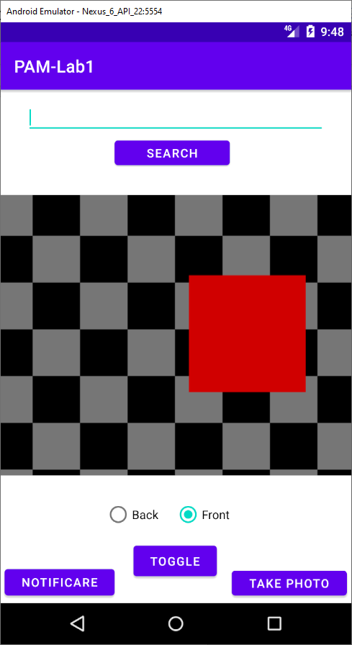 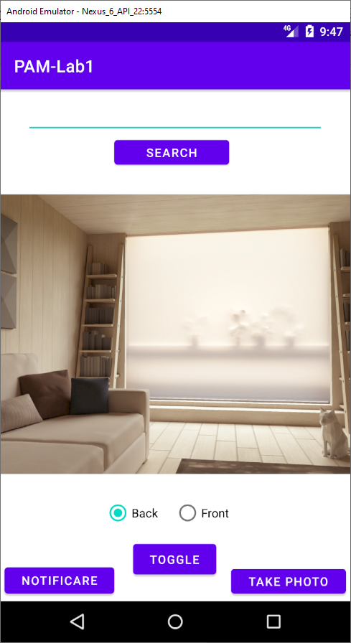

**Notification:**

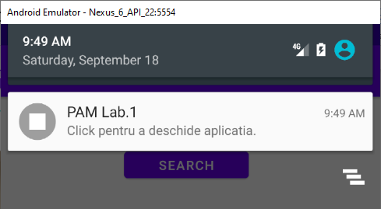

**Browser:**

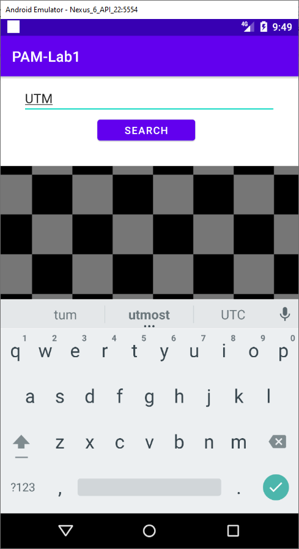 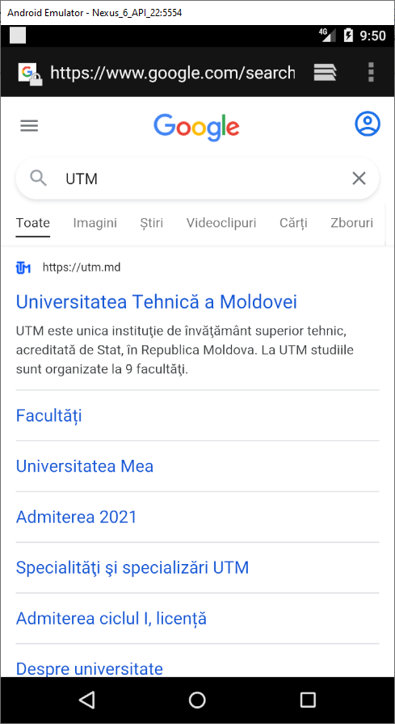

**Take photo:**

